Welcome to Mrs. McDougall's 4th Grade Class! (2024-2025)
Hi Families,
I'm excited to welcome you to 4th grade! My name is Stephanie McDougall. I've been teaching at Perkins since 2022. I previously taught 5th grade at Lakeview Fundamental. I am originally from New York and landed in sunny Florida in 2019. Outside of school, I love exploring the outdoors, cooking, traveling, playing games, and spending time with loved ones.
Harry Potter Theme
Our Harry Potter theme is just a fun way to spark excitement about reading, character development, and fantasy! We won't be brewing potions, casting spells, practicing witchcraft, or anything magical. Instead, we'll delve into important themes like friendship, fairness, integrity, and overcoming challenges. These themes also translate into our positive behavior system (ARTS):
- Always try your best
- Respect others and yourself
- Treat others kindly
- Safety First
The House Stole System
In the fall, students will be sorted into their houses and receive a special stole with their house letter. Throughout the year, they'll earn badges for accomplishments, big and small. These badges represent their hard work and choices. Last year, one student even earned a whopping 19 badges – that's impressive! Students get to keep their stoles as a reminder of their 4th-grade journey.
Get Ready for a Year of Great Reads!
We have some fantastic books lined up for 4th grade, including "Manatee Summer," "Gregor the Overlander," "Esperanza Rising," and "Save Me a Seat."
Summer Reading Recommendations
To keep those reading muscles strong, I strongly encourage everyone to read at least 30 minutes daily. This packet also includes a list of the Sunshine State Young Reader Award Books. If your child wants to participate in Battle of the Books later this year, consider reading at least 3 titles over the summer (there are 15 total!). They'll also be bringing home a summer read-along book, “Homer Price," along with choice board activities. Completing these activities will earn them some PBIS recognition when we return in August!
Looking for more reading options? Check out MYON, Newsela, and CommonLit – all free and accessible through CLEVER with their existing username/password.
Sharpening Math Skills Over Summer
In addition to reading, there are a couple of math skills I strongly encourage practicing:
- Basic math facts (addition, subtraction, multiplication, and division through 10). This will make 4th-grade math a breeze! A multiplication chart is included in this packet.
- Understanding place value through the thousands place. This is the foundation for future math concepts like multi-digit calculations, decimals, and measurement.
4th & 5th Grade Grading System
4th & 5th grade use Standards-Based Grading, which focuses on the mastery of skills (BEST Standards) in ELA, Math, Science, and Social Studies. Participation won't be a factor in grades; instead, students will be assessed based on how well they've grasped the material. There will be multiple opportunities throughout the year to demonstrate mastery. More detailed information about this grading system, retakes, and review resources will be sent out in the fall. In the meantime, if you'd like to explore the Florida Standards for 4th grade, here are the links:
- ELA
- Math
- Science
Summer Learning Matters!
Research shows that students who don't keep their brains engaged over the summer can lose learned skills. By reading regularly and incorporating basic math into everyday activities (shopping, cooking, etc.), you can help your child retain valuable knowledge.
Stay Connected!
Feel free to reach out via FOCUS or email if you have any questions or concerns over the summer.
Wishing you a fantastic summer!
Respectfully,
Stephanie McDougall
mcdougallst@pcsb.org

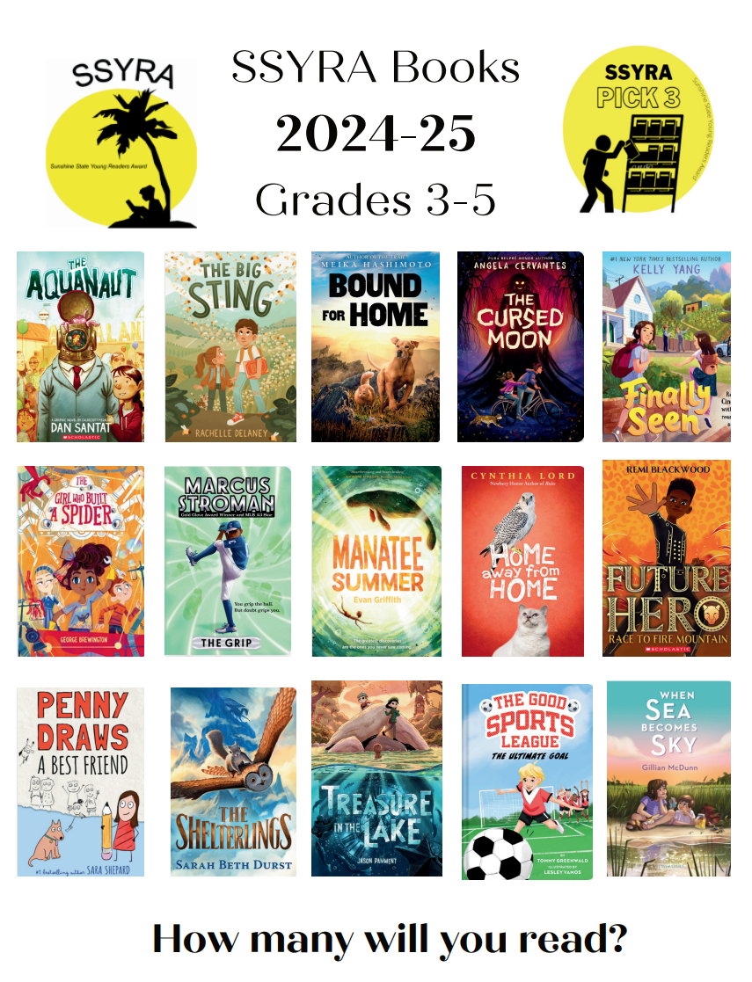

McDougall 4th Grade Supply List

Essentials:

- 4 composition notebooks
- 5 folders with PRONGS and POCKETS (preferably blue for math, green for science, red for ELA, yellow for social studies, and purple for homework and data)
- 24 pencils. Students go through a LOT in a year!
- Colored pencils
- USB headphones for daily use
- Water bottle
- 1 pack of sticky notes
- 2 boxes of tissues

Nice to have:
- A pack of looseleaf
- Supply pouch (not a box because it is too bulky for the desk)
- A highlighter

Homer Price Summer Reading Choice Board
Please choose at least 3 activities to complete as you read the book, Homer Price. Complete the activities on separate pieces of paper.
Turn your activities in when we come back to school on August 12.
Homer tames a skunk. If you could tame a wild animal, what kind of animal would you tame and why? | Freddy is disappointed to discover that the Super Duper is an ordinary person. If you could pick one superhero to be real, which would you choose and why? | Uncle Ulysses loves labor-saving devices. If you could invent a device that did one of your chores, what would it be?
Homer Price is set in a particular place (Centerburg) and time. Would you like the book  more or less if it took place during the present day? Why? | How is Centerburg like your hometown? How is it different? Would you like to have lived in Centerburg in the 1940s? Why or why not? | How is Homer like the kids you know today? How would Homer's life be different if he lived today?
Create a five frame “Super Duper” comic strip, complete with captions. | Think about something that you would like to invent; use your imagination.  Draw a picture of it, name it, and describe in detail what it does. | Which chapter was your favorite from this book? Why was it your favorite?

